***Quo Vadis*? Career paths of Brazilian regulators**

**ABSTRACT**

The post- or preterm career positions of regulators provide evidence for regulatory capture theories, questioning the independence of regulatory agencies (IRAs). This paper investigates the professional trajectories of Brazilian regulators based on sequence analysis, which places the careers of regulators in a broader context, viewing their mandates as endogenous to the rest of their careers. How do political affiliation and previous public sector experience influence the postterm professional positions of regulators? In which of the typical careers do regulators receive the most benefits after their terms in IRAs? Our analysis reveals five clusters of regulator career paths, in which most regulators do not transition between the public and private sectors but benefit in direct and indirect ways from serving their terms in IRAs. Regulators with previous expertise in the public sector, largely without political affiliations, are most likely to shift to the private sector after serving their terms.

**KEYWORDS:** regulators, board members, careers, independent regulatory agencies, revolving door

**1 INTRODUCTION**

Independent regulatory agencies (IRAs) have proliferated across a wide range of countries and sectors (Beblavy 2001; Christenssen 2005; Gilardi 2002; Jordana & Levy-Faur 2005; Levi-Faur & Jordana 2006; Gilardi *et al*. 2006; Wu 2008; Jordana *et al.* 2011). The diffusion of IRAs has found a particularly fertile context in several Latin American countries that have been deeply involved in market-oriented processes since the late 1980s and closely pressured by international organizations such as the World Bank and Organisation for Economic Cooperation and Development (OECD) (Levi‐Faur 2003; Jordana & Levi-Faur 2005; Dubash & Morgan 2012; Peci 2016). The growth in the number of regulatory institutions in the region, particularly during the 1990s, has been astounding (Jordana & Levi-Faur 2005; Gilardi *et al*. 2006). Brazil has championed the process, with more than 60 IRAs created at the federal, state and municipal levels of the government (Peci 2016; Meirelles 2006).

However, the formal adoption of IRAs does not necessarily translate into actual independent decision-making in different policymaking domains (Maggetti 2007; Jordana & Ramió 2010). The independence of IRAs from the government and from the regulated market is commonly associated with a set of expertise, professional and political requirements for IRAs’ board members, who are supposed to guarantee consistency and independent decision-making (Wu 2008).

Considering the key role of board members in IRAs’ decision-making processes, there is broad acceptance that the *de jure* independence of IRAs is intimately related to the *de facto* independence of their board members (Fernández‐i‐Marín *et al.* 2016). However, abundant evidence of the revolving-door trajectories of regulators in different policy domains fuels regulatory capture theories (see Zheng 2014), raising questions about how regulators can be independent in decision-making while serving their terms on IRAs’ boards. Understanding the professional trajectories of regulators, before and after their terms, can shed light on the *de facto* independence of IRAs. Where do the regulators come from, and where do they go after serving their terms on regulatory boards? Answering these questions can elucidate how the dynamic of regulatory independence enfolds in different policy contexts and has been the focus of relevant research.

Most studies have focused on prior or postterm trajectories of regulators, considering regulators’ mandates as the starting or the ending point of revolving doors. Studies about the prior experience of regulators in the US and in European countries indicate that most regulators share prior public sector expertise (Eckert 1981; Spiller 1990; Fernández‐i‐Marín *et al.* 2016). However, for regulators moving from the private sector to IRA boards, there is widespread concern that their decisions will be market-friendly (Cohen 1986). Additionally, the political affiliation of regulators is expressive in different national contexts (Thatcher 2005; Ennser-Jedenastik 2015; Fernández‐i‐Marín *et al.* 2016), and some research indicates that such affiliation might be a stronger predictor of regulatory capture than previous market experience (Gormley 1979). Research about the postterm trajectories of regulators also supports regulatory capture theories when it reveals that after their terms, most regulators with preagency jobs in the public sector are rewarded with well-paid jobs in the regulated industry (Eckert 1981; Spiller 1990).

By focusing on ex ante or ex post revolving-door dynamics, most of the studies assume that the prior or postterm professional trajectories of the regulators are separate and independent stages of their professional careers. However, it is reasonable to expect that a regulator’s prior professional career will influence his or her future career paths, as has been demonstrated in the analysis of the career path of European Union affairs managers (Coen & Vannoni 2016), and in extensive research related to different professional careers (Abbott & Hrycak 1990; Abbott & Tsay 2000; Aisenbrey & Fasang 2010; Dlouhy & Biemann 2015). In other words, career shifts or permanence in the private sector – after serving a term on an IRA’s board – may be hampered or catalyzed by prior career paths.

Another assumption underlying current research is the absence of barriers in career exchange between the public and private sector. In contrast to the US context (Eckert 1981; Spiller 1990), in many countries, the entry/exit options in public service are limited by public exams and rigid rules that may limit career exchange between the private and public sectors.

Summing up, regulators’ mandates should not be seen as something exogenous to the rest of their careers but should be put in a broader career context. Based on these new assumptions, in this paper, we rely on career sequence analysis and trace the professional careers of Brazilian regulators, contrasting their previous professional trajectories with their career paths after they serve their terms in regulatory agencies. Our study aims to answer the following questions: What is the typical career path of a Brazilian regulator? How do political affiliation and previous experience in the public or private sector influence their postterm career trajectories? Which of the typical careers receive more salary benefits after regulators serve their terms in IRAs?

Drawing on a sequence analysis of an original data set of 117 Brazilian regulators, we uncover five clusters of regulators’ career paths, most of which do not transition between public and private sectors (private or public) after serving their terms. However, we found that career shifts from the public to the private sector were more common for regulators with previous expertise in the public sector, with most of them, without political affiliations, revealing a “one-way” revolving door professional trajectory. Our research also indicates that regulators benefit from serving their terms in IRAs, substantially increasing their salaries in most of the clusters, with the most expressive gains for regulators with prior private experience who remain in the private sector after serving their terms. Potential benefits for regulators with prior public sector experience who shift to the private sector after their terms are related to their transit in consultancy companies.

**2 PROFESSIONAL TRAJECTORIES OF REGULATORS: WHAT DO WE KNOW**

Professional trajectories of regulators have always been of interest to research and have contributed to strengthening the outreach of regulatory capture theories. Most studies identify two types of revolving-door dynamics, *ex ante* and *ex post*, indicating that regulators with prospective or previous experience in the regulated sector tend to be more supportive of that sector in their regulatory decisions during the term (Coen & Vannoni 2016).

The dominant perspective privileges the postterm experience of the regulators, focusing on their ex-post performance incentives (Che 1995). These studies contribute to a negative view of regulatory capture by industry interests (Zheng 2014) and are generally corroborated by widely documented revolving-door phenomena, defined as the transit from government agencies to the companies they regulate, particularly in the US context (Che 1995). The assumption of regulators being guided by narrow, self-interested goals such as postgovernment personal wealth, causing them to exchange regulatory favors with interest groups, such as regulated markets or politicians, dominate the public choice school and are the most notable strand of the capture theories (Stigler 1971;1975; Zheng 2014), despite controversial research results (Gormley 1979; Cohen 1986; Makkai & Braithwaite 1992). The hypothesis that the expectation of the revolving door will make the regulator more prone to collude with firms became popular beyond the academic world.

Most of these studies focus on the “revolving door” revolving from the government to the regulated market, in other words, on the postterm experience after serving in a government agency. However, not all the examples of the revolving door refer to a temporary term served in the government agency, as in the IRA board members’ mandates we analyze in this research. As a consequence, the revolving door may reflect part of the longer professional trajectories of the regulators, ignoring their previous professional experience before they serve their terms.

Studies focusing on the prior experience of regulators before they serve their terms are also guided by the assumption that a regulator with previous experience in the regulated sector will be more supportive of that sector. However, research indicates that most regulators have prior expertise in the public sector, not in the private regulated sector (Eckert 1981; Spiller 1990; Fernández‐i‐Marín *et al.* 2016). For regulators moving from private industry to IRAs, there is widespread fear that they will be “friendlier” to the market because they have been socialized within the industry (Zheng 2014). Gormley (1979) observed that prior employment with the broadcasting industry affected the voting patterns of commissioners at the FCC but also found that the party affiliation of the commissioners, rather than their prior industry employment, was a better indicator of their voting behavior.

As a consequence, the political affiliation of regulators has become an interesting variable when analyzing how prior experience influences regulator behavior. Additional studies indicate that the political affiliation of regulators is expressive in different national contexts or sectors (Thatcher 2005; Fernández‐i‐Marín *et al.* 2016). Additionally, the politicization of board members’ appointees increases with the legal independence of the agencies (Ennser-Jedenastik 2015). In practice, political capture, not previous experience in private regulated markets, might influence regulators’ indications, as commonly expected. Research has shown that regulators with political ties are less sensitive to political changes, and the *de facto* independence of the regulators increases when they are appointed by the legislature instead of by executive direct appointments (Fernández‐i‐Marín *et al.* 2016).

Notwithstanding, the abovementioned theories of regulatory capture based on trajectories are built on several questionable assumptions. First, there is no conclusive evidence that the revolving door leads to regulatory capture during regulator mandates (Gormley 1979; Cohen 1986; Makkai & Braithwaite 1992). In addition, regulators who come from the public sector may also adopt market-friendly regulations. Incentives that lead to capture are criticized from the perspective of human-capital theory, which recognizes that regulators might be awarded a postterm job in the regulated market based on their expertise (Zheng 2014). Nonrational factors may influence regulatory decision bias, such as the regulator’s “worldview”, “culture” or social networks (Carpenter & Moss 2013). Moreover, regulators can be captured by other groups of interests, beyond regulated industries, such as bureaucracy or politics (Carpenter & Moss 2013); yet, capture theories privilege markets as the dominant players in the regulatory arena (Stigler 1971; Peltzman 1976; Laffont e Tirole 1991). Finally, revolving-door laws, which impose restrictions on regulators’ future career choices, may lower the quality of new regulators (Law and Long 2011).

Additionally, revolving door phenomena are commonly focused in partial assessments of regulators’ professional trajectories: from the government agencies to the market or from the market to the government agencies. Two studies in the North American context take a broader view of regulators’ professional trajectories, considering their previous and postterm experience, and will be highlighted here (Eckert 1981; Spiller 1990).

Eckert’s (1981) study focused on the precommission and postcommission jobs of three regulatory agencies (the Interstate Commerce Commission (ICC), the Civil Aeronautics Board (CAB), and the Federal Communications Commission (FCC)). First, he demonstrated that of 174 appointed regulated jobs, 84 (48%) had some precommission experience in the related public sector and only 37 (21%) previously held private sector jobs. In other words, if the commissions have been captured by any interest group, it has been by people from the related public sector. The study also indicates that career shifts from the private to the public sector after serving the term are less common: only 4% of 34 people who held precommission jobs in the related private sector took postcommission positions in the related public sector; 50% of them returned to private-sector positions after serving their terms. Second, of 142 commissioners, 72 (51%) took private-sector jobs after serving their terms. The study suggests that people with precommission experience in the related public sector used their terms as a stepping-stone to jobs in the related private sector, as was also done by people with previous experience in the related private sector. Better than half eventually took jobs as either attorneys or employees with regulated firms, regardless of the type of precommission trajectory.

In summary, the typical career path of regulators consists of strong performance in the public sector in the run-up to directing an IRA, with a high likelihood of subsequent allocation, either directly or indirectly, to the regulated industry previously under their jurisdiction, implying that regulators tended to be captured by the companies they regulated. The rewards that regulators can obtain from serving on an IRA’s board, considering they do not receive high salaries during their terms, comes from future gains.

Spiller (1990), based on data previously collected by Eckert (1981), analyzed regulators of the same regulatory agencies (focusing on the age of the agency, term of office, preagency and postagency experience, agency discretionary budget, etc.), considering not only the industry but also Congress’ interest in controlling the agencies. Spiller’s model recognizes the potential politicization of regulators’ appointments. Politicians may reward regulators for favorable outcomes by appointing them to more prestigious positions in the public sector or by increasing the agency’s budget. Eckert also found that of the 129 regulators, 75% came to the agency with public sector experience, and most half left to work directly or indirectly for the regulated industry. While 49 percent of patronage appointments went to work for industry after their terms, only a third of the regulators who came from the private sector did so. The study also revealed that patronage appointments and younger regulators have a higher probability of shifting to a regulated private industry job. Additionally, increases in discretionary budgets of the agencies reduce the probability of going to work for the regulated industry. Other findings refer to a reduced probability of the regulators working for the regulated industry in Republican administrations and to the impact of an ethics bill that reduced the probability of working for the industry.

Additionally, the “revolving door” phenomenon among regulators, when evidenced, contributes to a negative view related to regulatory capture by industry interests (Zheng 2014), despite controversial research results (Cohen 1986).

**3 CAREER PATH ANALYSIS OF REGULATORS**

In most research, entrance and exit in regulatory boards are assumed to be static factors that affect regulators in the same way throughout their careers (Cohen 1986). However, early career positions may affect postterm career positions (Abbott & Hrycak 1990; Abbott & Tsay 2000; Aisenbrey & Fasang 2010; Dlouhy & Biemann 2015), as Eckert (1981) and Spiller (1990) analyze for US regulators. Considering the career path of a regulator as a sequence, that is, as a succession of standard categorical states or events, seems a more plausible approach to understanding the professional trajectories of the regulators.

Therefore, the first research question we aim to answer in this study is as follows: What are the most common career sequences of Brazilian regulators? This explanatory analysis can help us to understand and further test several career paths, e.g., whether a regulator who has prior experience in the public sector has a higher probability of shifting to the private regulated sector after serving the term, as Eckert’s (1981) and Spiller’s (1990) analyses seem to suggest. The main outcome of this analysis is a description of clusters of typical career paths of Brazilian regulators (see Methodology for further discussion).

We focus on two characteristics of prior experience that might influence the postterm experience of the regulators: politicization and expertise, asking the following: Do political affiliation or public sector experience influence the probability of working for the private sector after serving a term on the regulatory board?

Indeed, there is a broad expectation that prior to their mandates, regulators need to be distinguished by a professional carrier marked by expertise (training and/or work experience) in the regulated sector. In many countries, including Brazil, appointees who serve a mandate in an IRA are required to demonstrate strong expertise in the regulated sector. Although board members are appointed by the President, they need to be formally approved by the legislature. Their strong expertise in the regulated sector needs to be demonstrated by prior professional/training experience, and their CVs are scrutinized in the legislative approval process.

However, as we have seen, studies have already indicated that most of the regulators come from the public sector, particularly in Brazil, where state-owned utility companies preceded privatization reforms. As a consequence, we expect a higher number of regulators to come from the public sector.

Additionally, in many contexts, as in Brazil, the transition from the private to the regulated sector is hampered by a set of legal requirements, such as competitive public exams. As a consequence, the probability of shifting from the private sector to the public sector might be lower than in contexts where such legal requirements do not exist.

As a consequence, our first hypothesis is as follows:

*H1. The probability of working for the private sector after the term is higher for regulators with prior expertise in the public sector than for regulators with prior experience in the private sector.*

An additional requirement relates to regulators’ apolitical profiles because professionals without political interests experience less interference in decision making, guaranteeing autonomy (Fernández‐i‐Marín *et al.* 2016). Indeed, it is expected that regulators with political connections will be diverted from technical and autonomous decision-making and be captured by politicians (Spiller 1990). However, research has demonstrated that regulators with political ties are less sensitive to political changes, continuing to serve their terms (Fernández‐i‐Marín *et al.* 2016). How do regulators’ political affiliations influence their probability of shifting to a different sector after serving their terms in IRAs?

According to capture theories, the political affiliation of the regulators indicates that they would be captured by politicians (instead of the regulated industry). Based on human-capital theories (Zheng 2014), the political affiliation of the regulators will overshadow their technical expertise, diminishing their probability of being hired in the private sector after serving their terms. As a consequence, our second hypothesis is as follows:

*H2. The probability of working for the private sector after the term is lower for regulators with political affiliations than for regulators without political affiliations.*

An additional question we aim to answer in this research is as follows: Which clusters of typical regulators’ careers receive more salary benefits in their postterm positions? Indeed, many of the narratives of the postterm experiences of regulators are fueled by the prospect of an increase in benefits in the postterm positions of the regulators. Considering data availability (see Data and Measurement section), we explore such potential gains in terms of salaries and market (consultancy or jobs in regulated companies) in post-term positions.

**4 METHODOLOGY**

***4.1 Data and measurement***

This study draws on an original dataset consisting of all Brazilian regulators (171) serving on IRA boards from 1997 (the first agency was created in 1996) to 2018. The regulators served in ten (10) federal regulatory agencies whose main activities and regulated sectors are briefly described in Table 1.

All Brazilian RIAs have a board composed of 4 to 5 members who are appointed by the President and go through legislative approval before taking office. Because we focused only on regulators’ full yearly information about their professional trajectories five years before and five years after the IRAs’ term, the final dataset we relied in this research contains the trajectories of 117 board members.

The main source of expertise data is the Federal Senate of Brazil, which scrutinizes the curricula vitae of every director nominated to compose the collegiate board of a federal regulatory agency. These CVs highlight the academic training, level of education and professional experience of professionals. We investigated the political affiliation of board members in the Supreme Electoral Tribunal (TSE) database, which provides a list of affiliates per party in each state of the federation. Data about salaries were extracted from the Annual Social Information Report (RAIS), an official registry of all formal workers in Brazil that indicates employer, occupation according to the Brazilian Classification of Occupations (CBO), compensation and work hours. Data on their postterm positions were also collected based on the RAIS database, a detailed search on LinkedIn, and websites for regulators who do not have complete information on the RAIS database because they work for their own consultancy companies. Finally, we also collected both governmental and nongovernmental print (newspapers, magazines) and electronic (websites) media to include information such as allegations of corruption, legal proceedings, and political scandals.

Table 2 reports individual variables and data sources considered in the research.

***4.2 Research design***

Several methods can be used to analyze the careers of the regulators, but we rely on sequence analysis (SA). Sequences are successions of standard categorical states or events, such as evolution of regimes, analysis of speeches, or elections (Blanchard & Fillieule 2011). Professional trajectories can also be seen from a sequence perspective because careers are a sequence of job positions over time (Spilerman 1977).

Sequence analysis applies longitudinal data techniques to compare career sequences to map patterns and has been extensively used in career research (Abbott & Hrycak 1990; Abbott & Tsay 2000; Aisenbrey & Fasang 2010; Dlouhy & Biemann 2015). SA has the advantage of considering the trajectory as a whole and not only the transitions, such as in survival analysis, and also it takes into account the order and duration of stages, something that factor analysis does not (Abbott & Hrycak 1990; Vannoni & John 2018).

SA was recently used to analyze European Union affairs managers (Coen & Vannoni 2016). Since the 1990s, SA has come to designate a methodological approach with five objectives: a) to describe and to represent sequences, grasping the general trend or pattern in a sample of individuals; b) to compare and classify sequences, inductively observing which typologies emerge from the sample and what social/ideological factors give it structure. SA proposes a way to measure the amount of commonality and difference by means of optimal matching analysis (OMA); c) sequence mining, looking for dominant patterns inside one of the typologies or defining a variable (such as politicization or public sector origin, in our case) *a priori*; finally, d) SA may be used to explain trajectories, searching for the causal relationship between external variables and clusters of similar trajectories that come out of SA (Blanchard & Fillieule 2011; Studer 2013;2016).

After running some preliminary tests (not included in the paper but available upon request), we observed only marginal differences between trajectories of men and women, academic or non-academic professionals, regulators or public servants in general, and private sector workers or consultants. Thus, only two of seven possible dimensions were taken into consideration: politically affiliated vs. non-affiliated and public vs. private sector.

Our empirical strategy follows three paths. First, we analyzed the data using standard statistical techniques, such as descriptive statistics, contingency tables, mosaic plots and chi-squared tests.

Second, we employ Optimal Matching Analysis(OMA), introduced in career analysis by Abbott and Hrycak (1990) and revised by Abbott and Tsay (2000), Aisenbrey and Fasang (2010), Biemann (2014) and Dlouhy and Biemann (2015). OMA has been widely accepted in career studies. Applying OMA to our research problem has a major advantage over *ex ante* classifications due to its flexibility to fit to the data, i.e., it is not necessary to impose any *ex ante* restriction on the grouping of the sequences. The algorithm compares sequences by pairs of states and calculates a distance index based on the replacement of different elements. Then, it calculates the distance between two sequences as the cost of transforming one into the other by considering the insertion/deletion and substitution of elements (Coen & Vannoni 2016). One must note that despite only two dimensions for each state, there are four possible states for each year; thus, in theory, there are 1,048,576 (410) possible strings.

Briefly, first OMA defines the distance between sequences as the number of changes needed to transform one string of sequence into another. The lower this "cost," the more similar these sequences are. Second, the operations allowed to transform one sequence into another are the substitution, insertion, and elimination (indel operations) of a given state. The output of the comparison between the strings is a symmetric matrix that displays the distance from one sequence to all others. Finally, this matrix is used to cluster sequences that are more or less similar, even though they are not exactly the same. These groups/clusters are the “ideal-typical” sequences, demonstrating recurrent patterns in the sample (Abbott & Hrycak 1990; Abbott 1991).

Finally, we verified which career paths of the clustersobtain more salary increases in postterm positions. Salaries are proxies for professional status or prestige, and we relied on data about the postterm position of the regulators (in private regulated companies or consultancy firms) to better understand regulators’ benefits in their postcommission jobs.

**5 DATA ANALYSIS AND DISCUSSION**

***5.1 Descriptive analysis of the strings***

We begin by presenting some descriptive statistics, analyzed with the TraMineR package (Gabadinho *et al.* 2011). Despite the large number or possibilities, in practice, there are only 27 strings that illustrate the career paths of Brazilian regulators. The reason for this is the low rate of transitions from one state to the other during the first or last five years of the sequence. When transitions take place, they tend to occur before and after the term on the regulatory board. This stability may be observed in the tempogram (Figure 1), where the 0 point refers to the term on the board of the IRA.

A tempogram is a graph that displays, year by year, the distribution of individuals across possible states. In the first five years and the last five years, the rule is stability, and the distribution of states does not change significantly. However, there is some change in the moment of leaving the mandate as a member of the board, that is, comparing before-and-after the mandate. There seems to be some migration from the public sector to the private sector, regardless of political affiliation. Also, there are some individuals that leave the dataset (NA), probably to establish their own consultancy firms.

As a result of the low number of observed sequences, the ten most common sequences correspond to 84.6% of occurrences, as displayed in Figure 2.

Some preliminary findings can be drawn from Figure 2. First, we can see that the most frequent preterm occupation of the regulators is in the public sector, as other studies suggest (Eckert 1981). The number of private employees in the preterm occupation is low but increases in the post-term occupations.

The most frequent string illustrates public servants, without political affiliation, who move to the private sector or become consultants in the regulated industry after serving their term (25 occurrences). The second string shows public servants, without political affiliation, who remain in public service after their term (24). The third string represents public servants, with political affiliation, who remain in public service after their term (14). The fourth string refers to private employees, without political affiliation, who tend to return to the regulated private sector (12). The fifth sequence shows public servants, with political affiliation, who are hired by the private sector after their term (10). Next, private employees, with political affiliation, remain in the regulated private sector (4).

From this simple descriptive analysis, one may infer that politically affiliated regulators face some obstacles in changing their positions from one sector to another, i.e., having a political affiliation is not translated into a postterm gain (if we consider shifting the sectors a potential benefit). It also neither precludes being appointed nor guarantees any market position postterm. Indeed, most private sector workers in the after-term come from the public sector, but they are not politically affiliated.

A chi-squared test, a contingency table (Table 3) and a mosaic plot (Figure 3) reveal whether there is some trajectory bias that can be attributed to IRAs. Indeed, the overall chi-squared test rejects the null hypothesis of no bias towards any IRA, at less than 0.001% of significance. A contingency table and a mosaic plot point out the sources of these biases, through the difference between observed (first line of each cell), expected (second line) and their respective standardized residuals (third line). Standardized residuals may be interpreted as ordinary t-statistic observed values.

Hence, according to standard confidence levels (10%, 5% and 1% for rejection of the null hypothesis), only two cells show significant differences between observed and expected values, and both refer to agencies that regulate segments of the transportation sector: ANAC and ANTAQ.

ANAC (the civil aviation agency) has a larger-than-expected proportion of regulators coming from the private sector (and eventually returning to private jobs), and ANTAQ (water transportation and ports) has the same for politically affiliated public servants, who tend to return to public service after their terms. These agencies follow different patterns from the rest of Brazilian IRAs, tending to be captured by private and political groups.

***5.2 Optimal matching analysis (OMA): the career paths of Brazilian regulators***

As in previous studies, we relied on Optimal Matching Analysis (OMA) to understand Brazilian regulators’ careers. In addition to the coding of sequences and the time frame, there are two critical decisions when applying OMA: the deletion/insertion and replacement costs between the states when applicable and the criterion for grouping the sequences. Simulations were conducted using the R statistical programming language. The TraMineR package was used for the sequence analysis, as described by Gabadinho *et al.* (2011). The TraMineR algorithm is essentially that of Needleman and Wunsch, with standard optimizations (Gabadinho *et al*. 2011).

The transition costs between states – in other words, the indel costs matrix - follow the transition probabilities. This choice has been a growing trend in the literature (Aisenbrey & Fasang 2010; Dlouhy & Biemann 2015). Mathematically, the transition cost from state *i* to state *j* (*i ≠ j*) is equal to 2 – *p(i|j) – p (j|i)*, where *p(i|j)* is the transition rate between states *i* and *j* in the sample. The rationale behind this approach is that the transitions observed more frequently are less costly than less frequent transitions. By definition, the probability of a transition from one state to itself is equal to one, which makes the transition cost zero, and the matrix is a symmetric one The indel costs matrix is in table 4. Hence, the most common transition is that from public servant, not affiliated to private employee, not affiliated (cost=1.88), followed by politically affiliated public-to-private transitions (cost=1.90). In turn, the least common transitions are not affiliated private employees that drop out Rais (cost=1.99).

The clustering method is Ward’s hierarchical cluster, a standard in the literature. The choice of the number of clusters involved the analysis of some measures available in the R cluster package of and visual dendrogram inspection. No definitive criterion for choosing the number of clusters exists, and there is a trade-off between analytical power and tractability in the choice of clusters – the number of clusters may vary from one to the number of observations itself. However, some methods and indicators aid researchers in this decision, but they often do not point towards a single solution. Some criteria for this choice are presented in Figure 4: the “elbow” graph, the Calinski-Harabasz (CH) and the silhouette measures. The “elbow” graph derives from the plot of the within sum of squares; since it will always will fall with the number of clusters, it the researcher’s responsibility to decide the cutoff point, i.e., where the decrease in the sum of squares is no more relevant to justify the increase in the number The CH measure is also a sum of squares, but weighted by the number of clusters (in this case, researchers should look for maximum points). The silhouette measure represents the average distance of a specific observation in relation to the other observations of the cluster to which this point belongs and compares this distance to the smallest average distance between this observation and the observations of the cluster to which it does not belong. The measure ranges between -1 (a situation where the observation is badly placed in its cluster, given that the average distance from it to another cluster is less than the average distance from the observations of its own cluster) and +1 (the opposite situation). In this case, researchers should choose the number of clusters that minimize the average silhouette.

Taking into account all these measures the dendogram (figure 5) and the analytical power, , we chose a five-fold solution. All code used to conduct the simulations and generate plots, as well as the simulation results presented herein, are available upon request. Not surprisingly, the five-cluster solution is very close to that previously presented in the descriptive analysis:

* Cluster 1 (n=27) - public servants, not affiliated, who then become private sector non-affiliated workers;
* Cluster 2 (n=23) – politically affiliated public servants, who return to their positions after their terms as regulators;
* Cluster 3 (n=15) - politically affiliated public servants, who manage to go to the private sector afterwards;
* Cluster 4 (n=33) – not politically affiliated public servants, who return to their positions after their terms;
* Cluster 5 (n=19) – not affiliated private workers.

As we can see from our clusters, the most important path career path of the Brazilian regulators refers to not politically affiliated public servants who return to their positions after serving their terms on the IRA board. However, the biggest career shifts are represented by not-politically-affiliated public servants who work in the private sector after their terms. Political affiliations seem to hinder any career shifts in post-term positions. We test these hypotheses in the next section.

***5.4 Postterm benefits of Brazilian regulators***

Finally, we verified which of the clusters obtain more salary benefits after serving their mandates in IRAs. Figure 7 depicts the before-and-after wages of IRA board members.

Perhaps surprisingly, former not-affiliated public servants (the red columns) do not seem to substantially increase their salariesin the private sector after their terms as regulators. As we can see, the public-to-private career, not affiliated (in red), is the one that receives similar salary benefits after serving the term (0 point). However, our reliance on the RAIS database hinders our knowledge of the actual benefits of this career because RAIS registers only the salaries, not other types of benefits, such as pensions, dividends or profits, which better illustrate the typical trajectory of this career. Indeed, most former public servants are not hired directly by regulated companies but work as consultants, many in their own companies. From this cluster, our qualitative analysis revealed at least eight regulators who are owners or partners of consultancy firms. Moreover, other regulators are retired military officers who earn Brazilian Armed Forces pension benefits in addition to their wages in the private sector. In other words, postterm benefits for this career are related not only to salaries but also to alternative forms of compensation.

The cluster that receives more salary benefits after the term is that of non-affiliated private sector regulators who return to the private sector after their mandates. Consequently, our analysis indicates that for regulators with prior private-sector experience, the IRA mandate is a form of potentializing their postterm benefits. However, one should notice that these regulators are rather few: 25 out of 117 trajectories. Additionally, this trajectory is more prominent in a few IRAs (e.g., Anac, the civil aviation agency has the highest number of regulators coming from the private sector). Moreover, we did not run a formal test for wage premia derived from the experience in the IRA because regulators have diverse professional backgrounds. Therefore, we cannot confirm whether former members of IRA boards earn more or less than their counterfactuals due to their status as IRA board members, but we can observe differences in terms of potential benefits for the main clusters.

**6 CONCLUSION**

This study focused on the career paths of Brazilian federal regulators, board members of independent regulatory agencies that were created after 1996. Our sequence analysis of the professional careers of Brazilian regulators indicates that postterm career options are related not only to the regulatory mandates but also to the preterm professional trajectories of the regulators. As a consequence, revolving door trajectories do not focus only on pre- or postterm experience but consider the full career trajectory of the regulators. The professional careers of typical Brazilian regulators are synthetized in five clusters that exhibit relative stability in terms of pre- versus postterm experience. Preterm experience in the public sector seems to influence the probability of shifting to the private sector after serving the term, but our analysis could not confirm the influence of the political affiliation of the regulators on their postterm positions.

As in other research contexts (e.g., EUA), most of the Brazilian regulators had previous experience in the public sector. However, the numbers are higher than in the North American context (where 48% of the regulators had precommission experience in the public sector). No less than 77 of 117 (66%) strings under analysis begin their professional trajectories in the public sector. The higher numbers reflect that most of the current private regulated companies used to be publicly owned, so a good number of the regulators used to work for these companies before privatization. Conversely, only 40 (34%) regulators came from the private sector, but there are differences depending on the agency (Anac, the civil aviation agency, is characterized by higher numbers of regulators with prior private sector experience compared to its peers), indicating that capture from the private sector might depend on the regulated sector. In general, the public sector is surely a “talent pool” for recruiting IRA board members.

Career changes from the public to the private sector are not as common as in the US, where better than half of regulators eventually took jobs as either attorneys or employees with regulated firms, regardless of the type of precommission trajectory. The numbers were higher for regulators with precommission experience in the related public sector: more than half of them took related private jobs (Eckert 1981). Our clusters of typical career paths of Brazilian regulators indicate that the largest clusters refer to former public employees with (23) or without political affiliation (33) who return to the public sector after their terms in IRAs. Regulators with prior experience in the private sector changing to the public sector after serving their terms are also very rare.

The only cluster capable of a meaningful revolving-door trajectory after serving their terms is that of not-politically-affiliated regulators with previous experience in the public sector. Indeed, most postmandate private sector workers come from the public sector. Of the 48 regulators who took a private sector job after their mandates, more than half are former public servants, confirming trends we observed in the US context for regulators with the same career patterns. Substantial career changes are limited to this career group, revealing the dominance of a “one-way” revolving door trajectory in the Brazilian context.

Our descriptive analysis indicated that political affiliations seem to be an obstacle for important career shifts in the postterm. Indeed, politically affiliated public servants, who return to their positions after their serving terms as regulators, are more numerous (23) than politically affiliated public servants, who manage to go to the private sector afterwards. As the number of regulators increases, the hypotheses can be retested in future studies.

Finally, most of the regulators benefit in terms of salary increases in their postterm positions. The cluster of originally private sector workers who manage to return to the private sector after serving their terms tends to be that of the best paid workers. Surprisingly, the only cluster that did not obtain any evident wage benefit after their terms is that of regulators who change their careers: public servant employees without political affiliation who work for the private sector after serving their terms. However, the qualitative analysis of their trajectories indicated that most of the regulators in this cluster have alternative benefits in addition to direct salaries and work for their own consultancy companies after serving their terms.

Public servants are probably chosen for IRA boards due to their specific experience – according to a human capital perspective – or even because they manage to expand the “market” for their skills – according to market expansion theory (Zheng 2014). This theory focuses on the incentive for regulators to expand the market demand for services they would be providing when they exit the government. “Regulocrats” make rules broad and complex enough to require expertise in interpretation/implementation. The same complex rules increase the private sector’s need to rely on their expertise after they serve on IRA boards. However, whether this is a rational calculus of the regulators or simply reflects the expansion of “regulocratic” culture remains an open question, demanding further investigation.

Finally, the trajectories of the regulators are dynamic. As the pool of Brazilian regulators increases, it is possible that we will observe some changing patterns in their professional trajectories. For example, the number of regulators with previous expertise in the regulated private sector or in other regulatory agencies is increasing over time. Future research should account for these potential changes. Additionally, other studies should analyze professional trajectories with some measure of regulatory quality.

**REFERENCES**

Abbott A, Hrycak A (1990) Measuring Resemblance in Sequence Data: An Optimal Matching Analysis of Musicians' Careers. *American Journal of Sociology* 96, 144–185.

Abbott A, Tsay A (2000) Sequence Analysis and Optimal Matching Methods in Sociology: Review and Prospect. *Sociological Methods & Research* 29, 3–33.

Aisenbrey S, Fasang AE (2010) New Life for Old Ideas: The" Second Wave" of Sequence Analysis Bringing the" Course" Back into the Life Course. *Sociological Methods & Research* 38, 420–462.

Beblavy M (2001) Understanding the Waves of Agencification and the Governance Problems they have Raised in Central and Eastern European Countries. *OECD Journal on Budgeting* 2, 121–139.

Biemann T, Datta DK (2014) Analyzing Sequence Data: Optimal Matching in Management Research. *Organizational Research Methods* 17, 51–76.

Blanchard, P & Fillieule, O (2011). Sequence Analysis for Political Science. Paper prepared for the 2011 Annual Meeting of the American Political Science Association, September 1-4, 2011.

Carpenter D, Moss DA (2013) *Preventing Regulatory Capture: Special Interest Influence and How to Limit it*. Cambridge University Press, Cambridge.

Che, YK (1995). Revolving doors and the optimal tolerance for agency collusion. *The Rand journal of economics*, 378-397.

Christensen T, Lægreid P (2005) *Regulatory Reforms and Agencification, Stein Rokkan Centre for Social Studies*. Working Paper 6-2005.

Coen, D, & Vannoni, M (2016). Sliding doors in Brussels: A career path analysis of EU affairs managers. *European Journal of Political Research*, *55*, 811-826.

Cohen JE (1986) The Dynamics of the "Revolving Door" on the FCC. *American Journal of Political Science* 30, 689–708.

Dlouhy K, Biemann T (2015) Optimal Matching Analysis in Career Research: A Review and Some Best-Practice Recommendations. *Journal of Vocational Behavior* 90, 163–173.

Dubash NK, Morgan B (2012) Understanding the Rise of the Regulatory State of the South. *Regulation & Governance* 6, 261–281.

Eckert RD (1981) The Life Cycle of Regulatory Commissioners. *The Journal of Law and Economics* 24, 113–120.

Ennser-Jedenastik L (2015) The Politicization of Regulatory Agencies: Between Partisan Influence and Formal Independence. *Journal of Public Administration Research and Theory* 26, 507–518.

Fernández‐i‐Marín X, Jordana J, Bianculli AC (2016) Are Regulatory Agencies Independent in Practice? Evidence from Board Members in Spain. *Regulation & Governance* 10, 230–247.

Gabadinho A, Ritschard G, Mueller NS, Studer M (2011) Analyzing and Visualizing State Sequences in R with TraMineR. *Journal of Statistical Software* 40, 1–37.

Gilardi F (2002) Policy Credibility and Delegation to Independent Regulatory Agencies: A Comparative Empirical Analysis. *Journal of European Public Policy* 9, 873–893.

Gilardi, F, Jordana, J, & Levi-Faur, D (2006). Regulation in the age of globalization: the diffusion of regulatory agencies across Europe and Latin America. *Privatisation and market development: global movements in public policy ideas*, 127-147.

Gormley WT (1979) A Test of the Revolving Door Hypothesis at the FCC. *American Journal of Political Science* 23, 665–683.

Jordana J, Levi-Faur D (2005) The Diffusion of Regulatory Capitalism in Latin America: Sectoral and National Channels in the Making of a New Order. *The Annals of the American Academy of Political and Social Science* 598, 102–124.

Jordana J, Levi-Faur D, i Marín XF (2011) The Global Diffusion of Regulatory Agencies: Channels of Transfer and Stages of Diffusion. *Comparative Political Studies* 44, 1343–1369.

Jordana J, Ramió C (2010) Delegation, Presidential Regimes, and Latin American Regulatory Agencies. *Journal of Politics in Latin America* 2, 3–30.

Laffont, J, & Tirole, J (1991). The politics of government decision-making: A theory of regulatory capture. *The quarterly journal of economics*, *106*(4), 1089-1127.

Law, MT, & Long, CX (2011). Revolving door laws and state public utility commissioners. *Regulation & Governance*, *5*(4), 405-424.

Levi‐Faur D (2003) The Politics of Liberalisation: Privatisation and Regulation‐for‐Competition in Europe's and Latin America's Telecoms and Electricity Industries. *European Journal of Political Research* 42, 705–740.

Levi-Faur D, Jordana J (2006) Toward a Latin American Regulatory State? The Diffusion of Autonomous Regulatory Agencies across Countries and Sectors. *International Journal of Public Administration* 29, 335–366.

Maggetti M (2007) De facto Independence after Delegation: A Fuzzy‐Set Analysis. *Regulation & Governance* 1, 271–294.

Makkai T, Braithwaite J (1992) In and Out of the Revolving Door: Making Sense of Regulatory Capture. *Journal of Public Policy* 12, 61–78.

Meirelles F, Oliva R (2006) Delegation and Political Control of the Regulatory Agencies in Brazil. *Revista de Administração Pública* 40, 545–565.

Peci A (2016) Regulatory Reform and a Better Regulation Agenda: Traveling from Center to Periphery. In: Klassen TR, Cepiku D, Lah TJ (eds) *The Routledge Handbook of Global Public Policy and Administration*, pp. 217–225. Taylor & Francis, London, New York.

Peltzman S (1976) Toward A More General Theory of Regulation. *Journal of Law and Economics* 19, 211–240.

Spilerman, S (1977). Careers, labor market structure, and socioeconomic achievement. *American journal of Sociology*, *83*(3), 551-593.

Spiller PT (1990) Politicians, Interest Groups, and Regulators: A Multiple-Principals Agency Theory of Regulation, or" Let Them Be Bribed". *The Journal of Law and Economics* 33, 65–101.

Stigler GJ (1975) *The Citizen and the State: Essays on Regulation*. University of Chicago Press, Chicago.

*Stigler G (1971) The Theory of Economic Regulation. The Bell Journal of Economics and Management Science 2, 3–21.*

Studer M (2013) *WeightedCluster Library Manual: A practical Guide to Creating Typologies of Trajectories in the Social Sciences with R (LIVES Working Papers, 24)*. University of Geneva Institute for Demographic and Life Course Studies, Geneva, Switzerland.

Studer M, Ritschard G (2016) What Matters in Differences between Life Trajectories: A Comparative Review of Sequence Dissimilarity Measures. *Journal of the Royal Statistical Society: Series A (Statistics in Society)* 179, 481–511.

Thatcher M (2005) The Third Force? Independent Regulatory Agencies and Elected Politicians in Europe. *Governance* 18, 347–373.

Wu I (2008) Who Regulates Phones, Television, and the Internet? What Makes a Communications Regulator Independent and Why it Matters. *Perspectives on Politics* 6, 769–783.

Zheng W (2014) The Revolving Door. *Notre Dame Law Review* 90, 1265.

**ENDNOTES**

**TABLES**

**Table 1.** Brazilian Federal Regulatory Agencies

|  |  |  |  |
| --- | --- | --- | --- |
| ***Agency*** | ***Type of Regulated sector*** | ***Type of Regulation*** | ***Sector*** |
| ANA  National Water Agency | Private and Public | Social - environmental | Hydric resources |
| ANAC  National Civil Aviation Agency | Private and Public | Economic | Civil Aviation, Airports infrastructure |
| ANATEL  National Agency of Telecommunications | Public and Private | Economic | Telecommunications |
| ANCINE  National Cinema Agency | Public and Private | Social (Funding) | Video, phonographic and cinematographic sector |
| ANEEL  National Agency of Electrical Energy | Public and private | Economic | Generation, transmission and distribution of electrical energy |
| ANP  National Agency of Oil and Gas | Public and private | Economic | Oil, gas, and biofuels |
| ANS  National Health Agency | Private | Economic and Social | Private Health Insurance |
| ANTAQ  National Agency of Water Transportation | Public and private | Economic | Water transportation and ports |
| ANTT  National Agency of Transportation | Public and private | Economic | Railways, highways, and railroad infrastructure |
| ANVISA  National Health Surveillance Agency | Public and private | Social | Sanitary surveillance of products, services, ports, airports and borders. |

Source: Peci (2016)

**Table 2.** Study Variables and Data Sources

|  |  |  |
| --- | --- | --- |
| Variables | Definitions | Data Sources |
| Gender | Man or Woman | RAIS |
| Political Affiliation | If the regulator has a political affiliation with a specific party, registered in each state of the federation and/or was elected or holds a political appointment in the government. | TSE and Senate |
| Academia | If one has a Doctoral or Master of Science degree and/or holds a position in academia | Senate |
| Regulatory Agency | If one is a public servant on behalf of a regulatory agency | Senate |
| Public Sector | If one is a public servant on behalf of any government department excluding regulatory agencies | Senate |
| Industry | If one works in the regulated or private industry | RAIS and Senate |
| Consultancy | If one works as a consultant that provides professional advice to the regulated industry | RAIS, Senate, others |

**Table 3.** Types of Trajectories Per Agency

|  |  |  |  |  |  |  |
| --- | --- | --- | --- | --- | --- | --- |
| IRA | Others | Always private, not affiliated | Always public, affiliated | Always public, not affiliated | Public to private, affiliated | Public to private, not affiliated |
| ANP | 3  3.06  (-0.04) | 2  1.15  (0.88) | 2  2.2  (-0.16) | 2  0.96  (1.17) | 1  2.3  (-1.01) | 1  1.34  (-0.33) |
| ANAC | 4  3.9  (0.07) | 4  1.46  (2.37) | 1  2.8  (-1.28) | 1  1.22  (-0.22) | 3  2.92  (0.05) | 1  1.7  (-0.61) |
| ANATEL | 4  4.45  (-0.27) | 1  1.67  (-0.59) | 4  3.2  (0.54) | 2  1.39  (0.58) | 3  3.34  (-0.22) | 2  1.95  (0.04) |
| ANCINE | 3  2.78  (0.16) | 1  1.04  (-0.05) | 1  2  (-0.83) | 1  0.87  (0.15) | 2  2.09  (-0.07) | 2  1.22  (0.79) |
| ANEEL | 5  4.17  (0.51) | 0  1.57  (-1.42) | 5  3  (1.38) | 1  1.3  (-0.3) | 2  3.13  (-0.77) | 2  1.83  (0.15) |
| ANS | 5  4.45  (0.33) | 3  1.67  (1.17) | 3  3.2  (-0.13) | 0  1.39  (-1.33) | 3  3.34  (-0.22) | 2  1.95  (0.04) |
| ANTAQ | 1  1.95  (-0.82) | 0  0.73  (-0.93) | 4  1.4  (2.54) | 0  0.61  (-0.84) | 1  1.46  (-0.44) | 1  0.85  (0.18) |
| ANTT | 2  2.23  (-0.18) | 0  0.83  (-1) | 2  1.6  (0.37) | 1  0.7  (0.4) | 3  1.67  (1.2) | 0  0.97  (-1.09) |
| ANVISA | 3  3.06  (-0.04) | 0  1.15  (-1.19) | 1  2.2  (-0.95) | 1  0.96  (0.05) | 4  2.3  (1.33) | 2  1.34  (0.64) |
| ANA | 2  1.95  (0.05) | 1  0.73  (0.34) | 0  1.4  (-1.37) | 1  0.61  (0.54) | 2  1.46  (0.52) | 1  0.85  (0.18) |

Note: observed and expected values in the first two lines, and standardized differences between parentheses.

**Table 4.** Transition costs between states (or indel costs)

|  |  |  |  |  |  |
| --- | --- | --- | --- | --- | --- |
|  | Out of RAIS | Not affiliated, private employee | Not affiliated, public servant | Politically affiliated, private employee | Politically affiliated, public servant |
| Out of Rais | 0 | 1,988722 | 1,985948 | 1,967742 | 1,978448 |
| Not affiliated, private employee | 1,988722 | 0 | 1,884198 | 2 | 2 |
| Not affiliated, public servant | 1,985948 | 1,884198 | 0 | 2 | 2 |
| Politically affiliated, private employee | 1,967742 | 2 | 2 | 0 | 1,907397 |
| Politically affiliated, public servant | 1,978448 | 2 | 2 | 1,907397 | 0 |

Source: Own elaboration.







**FIGURE LEGENDS**

**Figure 1.** Tempogram of the sequences: Regulators, five years before and after their terms

**Figure 2.** Ten most common sequences

**Figure 3.** Mosaic plot: Types of trajectories per agency

**Figure 4.** Some indicators regarding the number of Clusters: CH, Silhouette and Elbow Graphs

**Figure 5.** Dendrogram of OMA: 5-cluster solution

**Figure 6.** Tempogram: 5 cluster solution

**Figure 7.** Wages by professional trajectory, 5 years before and after a mandate at an IRA

**FIGURES**

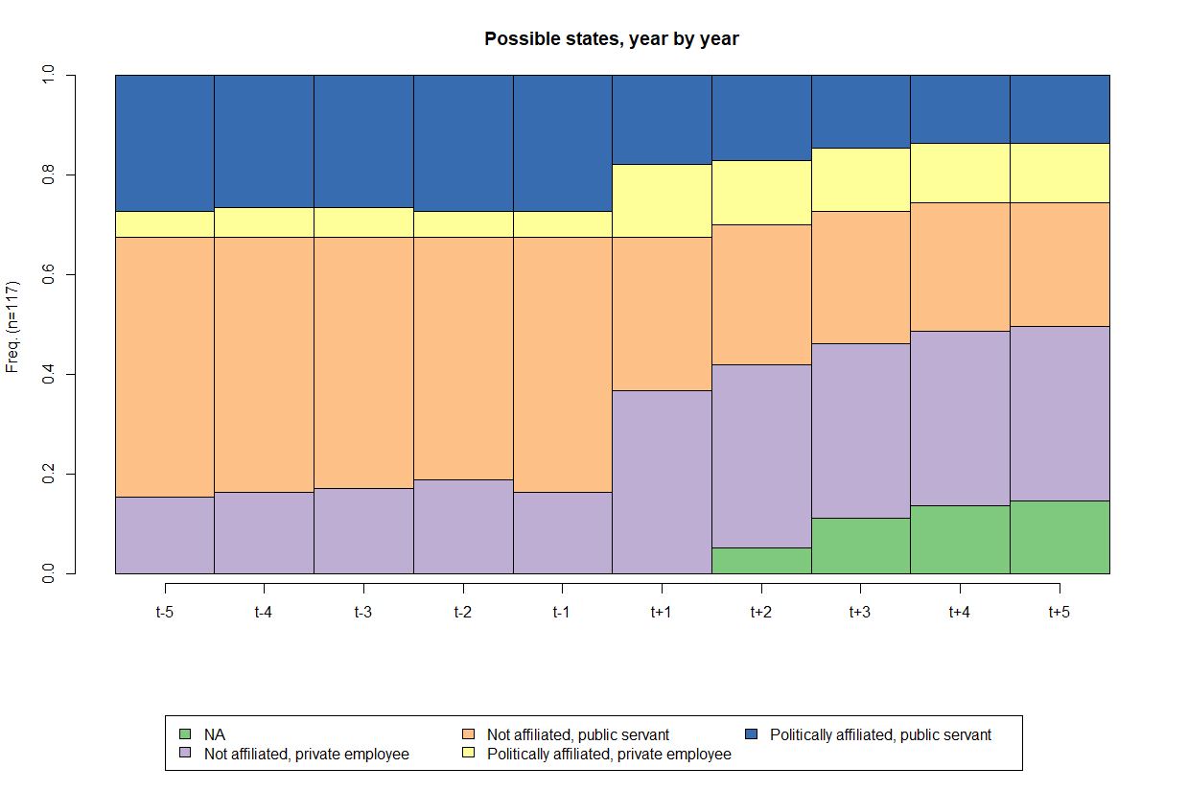

**Figure 1**

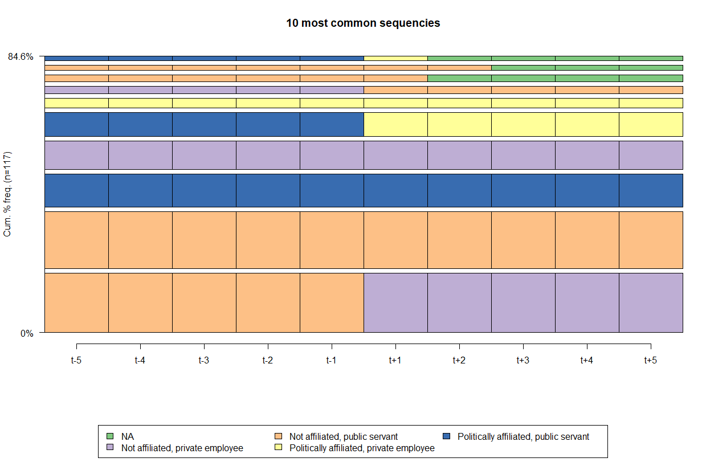

**Figure 2**

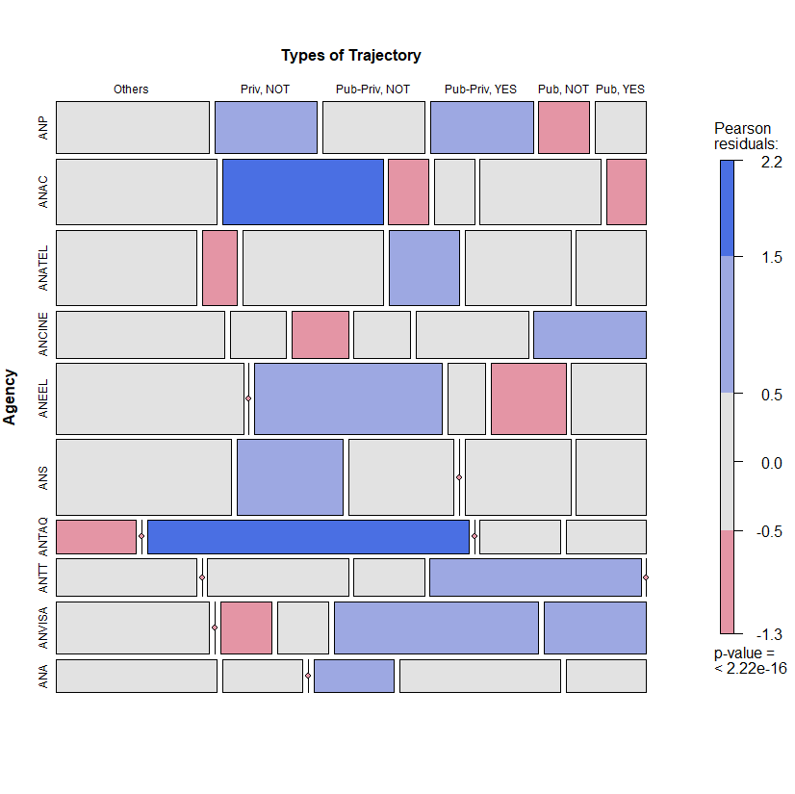

**Figure 3**

**Figure 4**

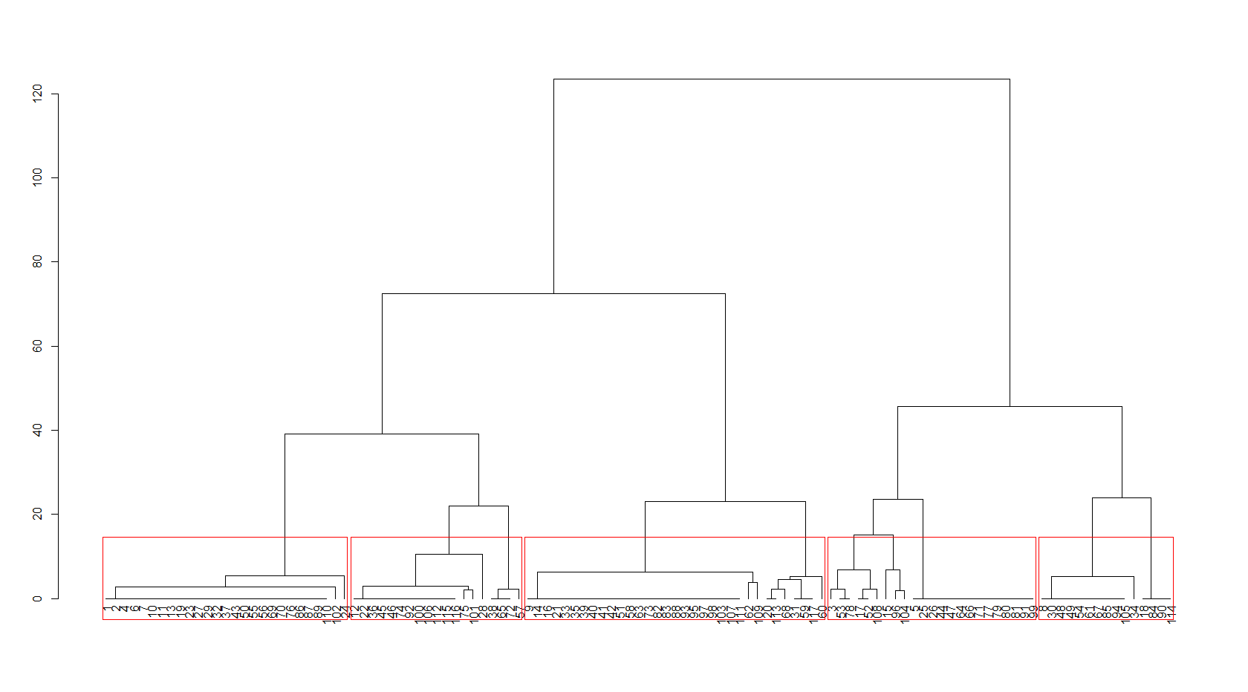

**Figure 5**

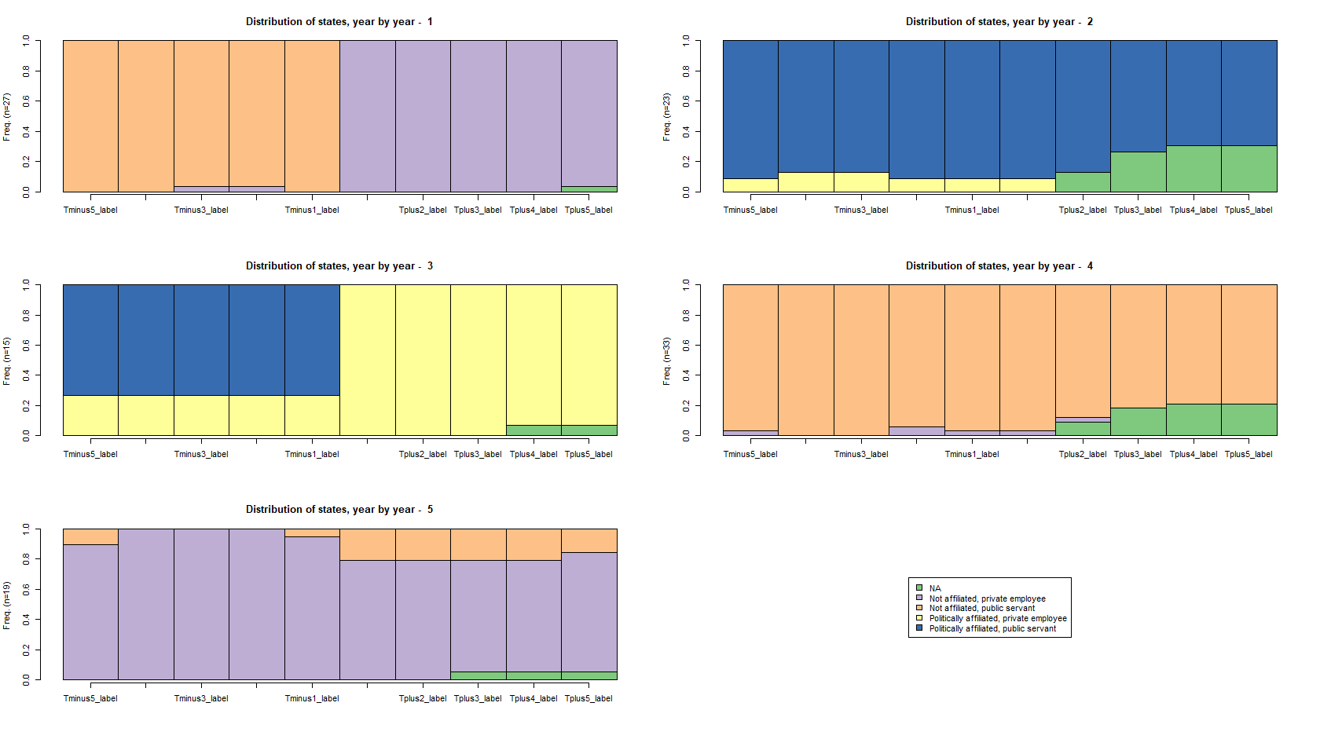

**Figure 6**

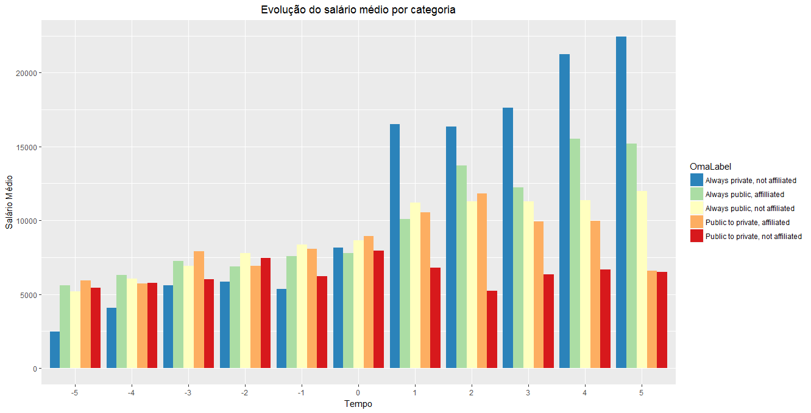

**Figure 7**